Student Activities Fund review board proposal
Mark Neubauer
Submission Date: 10/2/16

“Gym Equipment Proposal"

Introduction
NJIT has long held the value of athletics in high regard. Most notable is the recent announcement of a brand new, $100 million dollar Wellness and Event Center, set to be completed during the 2017-2018 school year. The current athletic center has much-need improvements to be made, especially in the gym. In particular there is a shortage of equipment like barbells, meaning that students often have to wait around in order to perform a certain exercise.
Significance
We hold strong to the belief that enriching the body also serves to strengthen the mind. Working out is a great way to stay in shape and relieve stress. It is important that the students of NJIT exercise to stay in shape and improve their overall fitness. Regular exercise can increase energy levels, focus and improve cognition. We believe that New Jersey Institute of Technology should invest in gym equipment that would allow its students to have a better gym experience.
The need for new gym equipment has the support of Brian Callahan, the Assistant Director of Physical Education. With the assistance of some members of the Athletics Department, we were able to find the cheapest prices for these items. It is their recommendation that SAFRB approve the equipment listed below.

Solution
Therefore, we the students of NJIT, would like to see equipment that would allow us to have a more complete gym experience. Specifically, this includes new barbells for squatting, deadlifting and benching exercises. Barbells, which are used for many different activities, are the most important item in the gym. Unfortunately, there are not enough barbells to accommodate all the benches, squat racks and deadlifting platforms. Three new barbells would mean that each of these spaces would be able to have its own barbell, cutting down on wait time. The Olympic EZ Curl Bar can be used for biceps and triceps work. Like the barbells, it is recommended we get at least three of these items. A barbell jack, which is used to easily load and unload huge weights from deadlifting bars would also serve to reduce wait time, as well as reduce back strain from bending over. One of the walls near the dumbbell racks is empty, and is in need of full-length mirror. Gym-goers can use the mirror to check their form, helping to reduce injury and to optimize results. Finally, the gym lacks equipment specific to lower back extension and glute & hamstring exercises. The reverse hyper back machine and GHD machine would accomplish this purpose. We are open to any and all discussion with the Athletics department and NJIT Administration to reach our goal.

Price List
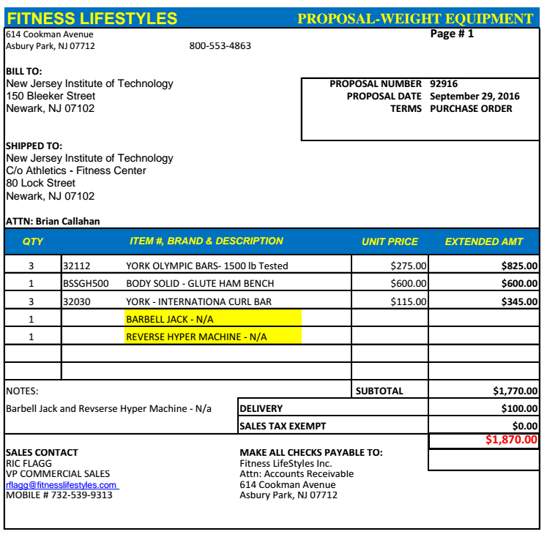

Appendix
