Student Activities Fund review board proposal
Panchajanya Vangapandu
Kellen Kadakia
Mark Neubauer
Submission Date: 10/02/16

"Project Highlander: an Outdoor Sculpture Proposal"

Introduction

The New Jersey Institute of Technology, though a premier university for those pursuing a career in various STEM fields, has areas that could use improvement. One such area is school spirit and overall student happiness. As of 2015, according to the Princeton Review, NJIT ranks 3rd for unhappiest college students, and according to The Daily Caller, NJIT has the 19th “ugliest college campus in America”. NJIT’s campus has been described as “bleak,” “gloomy,” “dull,” and “boring.” This sort of reputation about the campus contributes to poor morale and can even deter students from applying to NJIT.

Significance

One of the main sources of school spirit for colleges and universities is through sports teams. For example, the large turnout to football games at Rutgers University brings the college community together and helps students at this universities to have a stronger bond. It is important that students strongly identify with the mascot and symbol of their school. Most people, even those that don’t attend the school, has heard of the Rutgers University Scarlet Knights.
School spirit often comes with a physical display of the school colors and the school mascot in a pivotal and central part of the school’s campus. Some school’s mascots are synonymous with the school’s names such as the Princeton Tigers or aforementioned Rutgers Scarlet Knights. At New Jersey Institute of Technology, many freshmen are unaware that the school mascot was a Highlander, and some of them don’t even know what a Highlander is. This is not due to the lack of quality in our sports teams; there is simply a lack of awareness of the Highlander mascot. If NJIT is going support and showcase its sports teams, it needs to make a greater effort to solidify the connection its students have with the Highlander.
The lack of school spirit is amplified by the fact that the NJIT Highlander is not boldly displayed on central parts of campus. The building signs and pennants on the street lights show the iconic red “NJIT” logo with the signature curved underline that connects to the “T” (see Fig.1).

Fig. 1 NJIT logo commonly displayed on campus

In addition to a lack of spirit, NJIT also doesn’t have a central landmark on its campus. The only landmarks on NJIT’s campus are the red sign in front of Eberhardt Hall and the clock tower between the Campus Center and Fenster Hall. Both of these, however, are off to the side and corner of the campus. The true center of campus, the plaza between the upper and lower greens, is fairly unremarkable. Statues and sculptures are seen as an active part of campus liveliness. Some universities have statutes that are a symbol of pride, such as the RevolUtionary Monument at Rutgers-New Brunswick (see Fig. 2). If NJIT installed a similar monument that actively showcased the Highlander mascot, it would serve to promote a stronger identity and boos the school spirit of the student body.
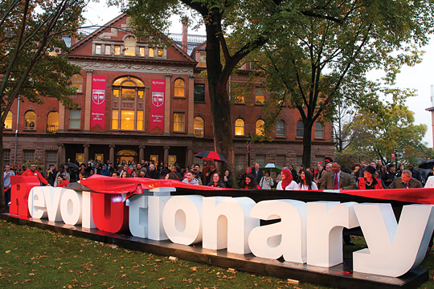
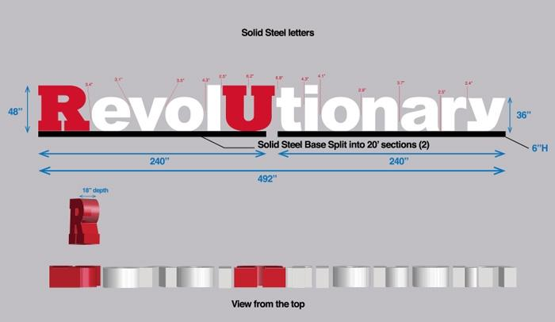

Fig. 2 Rutgers-New Brunswick "RevolUtionary" Monument

Solution

There are a series of new capital investments on campus that will greatly improve the school as well as make it more visually appealing. The main aspects of this initiative include the new Wellness and Events (WEC) center, the new Life Sciences and Engineering building, and the renovation of the Central King Building. With this proposal, we would like to contribute to this initiative by beautifying the central plaza area of the campus. The goal is to create a new landmark in the center of campus, a place where students will see a prominent display of school spirit.
This proposal advocates for the purchase and installation of a large sculpture of the Highlander logo (see Fig. 3). The logo in question consists of the Highlander mascot parading the front with his sword going through the “NJIT” letters. This design resonates more with NJIT school spirit than the official NJIT logo (Fig. 1). Prominently displayed in its centralized location, it could become the very centerpiece of school pride that NJIT. This idea has been successful when implemented in other universities and will have the same effect at New Jersey Institute of Technology. The bright colors and prominence of the school mascot could create a rallying point before every home game, during Highlander Games and other outdoor events hosted by the school, before finals, a meeting place for tours, and a location to make students feel more at home. The NJIT Highlander sculpture can establish new traditions for all future students, such symbol of luck before our exams, to representing the school message that a highlander means a warrior and that there is a warrior in each of NJIT’s students.
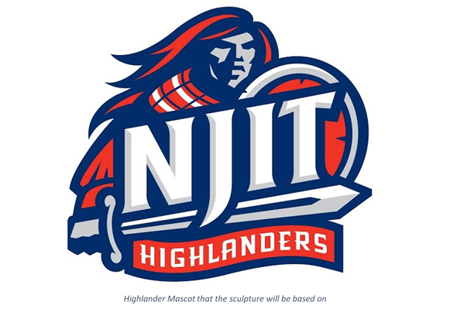

Fig 3. NJIT Highlander logo that will serve as the inspiration for the proposed statue

There are specifications that should be met in order to have a successful sculpture that instills the ideas of NJIT. The first one is size. If it is too small and not easily noticed will defeat its purpose. It should large and bold enough that it can be seen from the Honors building all the way to the Library, to ensure maximum visibility on campus. The Highlander sculpture will rest on a solid base platform of 8ft long x 3ft wide x 2ft high. This base increases the height of the overall entire statute without distorting its dimensions. The base also ensures a level surface for the sculpture to be placed on. The sculpture itself (Fig. 3) will be 6 feet high with the other dimensions scaled appropriately. It will be built using solid steel, to prevent rusting and damage in bad weather. Using good materials ensures that it stands as long as possible.

Cost and Location

The decision to build this monument was inspired by the Rutgers RevolUtionary sculpture that was donated to Rutgers University by Johnson & Johnson. The sculpture was fabricated by Roe Fabricators, Inc. Based on the quality of their work in the past, Roe Fabricators would be the ideal manufacturer for this project. After contacting their department, we obtained an approximate quote from a company representative. Roe Fabricators will be responsible for the complete process, including designing, manufacturing installing this sculpture. Installation would consist of a truck to deliver the sculpture to the approved location with accessible flat ground. Based on the specifications (size, colors, base and installation), the total cost would be $29,800.

Location: Edge of New Athletic Turf

Pros:
  - Will advertise the new Athletic Center
  - Will truly be part of the “New Campus” initiative
  - Will have steps right in front of it so people can sit and relax near it
- Cons:
  - Will have to wait until 2018 to unveil
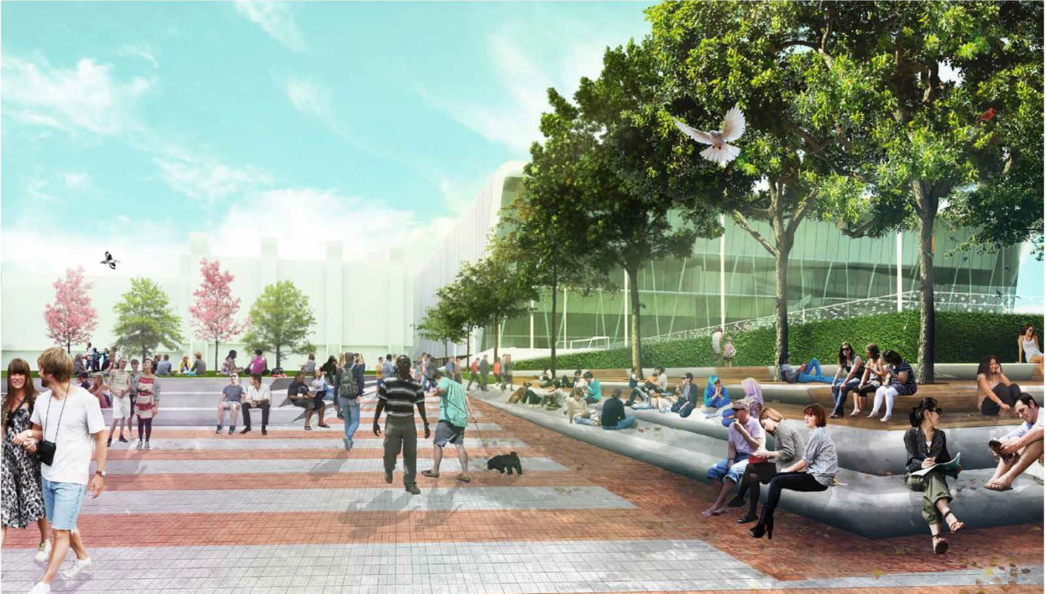
Fig 4. NJIT Highlander sculpture will go at the top of the stairs

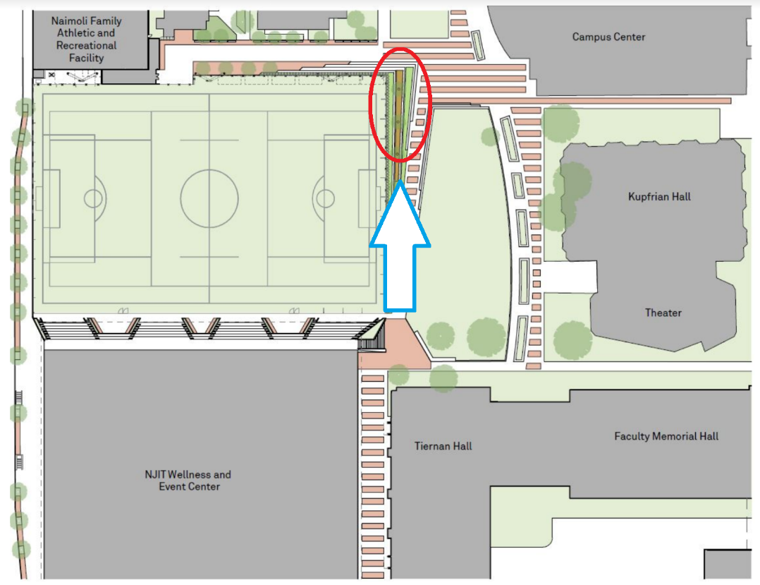

Fig 5. NJIT Highlander sculpture will go at the top of the stairs

Total Cost: $29,800

