Student Activities Fund review board proposal
Nithisha Prasad
Mark Neubauer
Submission Date: 10/02/16

"NJIT Library Charging Lockers Proposal"

Introduction
The library is a place for students to get their work done, read a book, use a computer or printer, meet with a group, or to simply hang out. Students spend much of their time in the library and many come across the same problem: their devices run out of battery. Laptops and phones are an essential part of education today, and it’s important that students are able to stay connected. Unfortunately, the library building does not have nearly enough outlets to meet the high demand, meaning many students cannot find anywhere to charge their devices.
There are more students who need to charge their devices in the library than there are available outlets. Students should be able to charge their electronics whenever they need to and not worry about being unable to submit an assignment or make a phone call. .
Significance
NJIT prides itself on being New Jersey’s Science and Technology University, a pioneer in research and education. The university needs to keep up with technology and adapt to provide its students with the best experience possible and prepare them for the future. This includes ensuring students have access to the technology they need; shortcomings that hinder this must be addressed. One of the most pressing issues is the lack of charging ports for laptops and cellphones in a space where it is most necessary: the library.
With a student body that is very dependent upon electronics, it is important to make sure their educational needs are met. As the school moves closer to fulfilling its 2020 vision, the student and faculty reliance upon tablets, cell phones and electronic notetaking will increase. There should be additional charging stations to build upon the existing outlet infrastructure on campus.

Solution
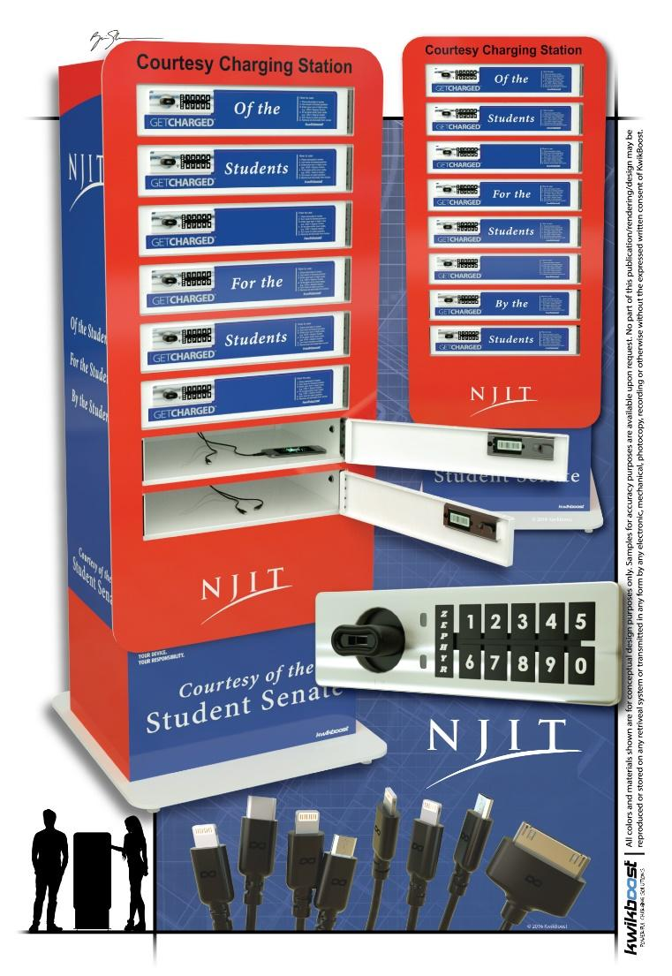
This proposal does not suggest an expensive and complicated overhaul to increase the number of wall outlets in the library. Rather, by purchasing and installing charging stations, a wall outlet will be able to service up to eight students at once rather than the typical two. The charging stations will also have a variety of chargers to match every laptop, Android and Apple electronic device. This is extremely convenient to students, especially commuters or students spending long hours studying in the library.
Kwikboost is a company that specializes in charging stations, and have been used in a variety of colleges and universities across the nation. Included below is recommended item list, which includes the charging station model, how many of each should be purchased, and where they would make the biggest difference in the library.This includes the CL8 Charging Locker, which would go in densely used areas of the library, such as the basement and 2nd floor. This type of charging station includes 8 lockers with built-in, electronic locks that can be reset for each new user. The locker itself has a variety of different chargers, such as android, microUSB and Iphone. Students can leave their valuable electronics here safely while they charge.
It is secure and visually appealing, because it can be customized to display any brand, or in this case, the NJIT logo. The charging lockers will serve a variety of purposes, one being a visual reminder that this university is responsive to the needs of its students.
This proposal has the full endorsement of Ann Hoang and the rest of the Library staff.

Cost and Locations
C8 Kwikboost Power Locker
C8 Kwikboost Power Locker - $5495 each (8 lockers)
The following locations were determined from a walkthrough with the Library staff, Mike Thompson from Physical Plant, and Public Safety
OPTION #3:
- Library First Floor 2
______________________________________________________________________________
Total Units: 2 Lockers = (2)($5495) = $10,990
Installation: (2)($50) = $100
______________________________________________________________________________
Total Cost $11,090
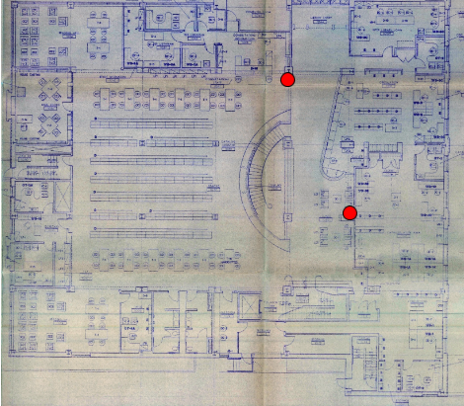

Proposed locations for Charging Lockers on the 1st Floor of the Library
Appendix

